
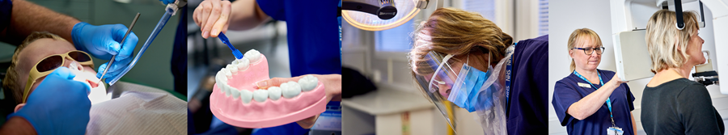

Your NHS dentistry and oral health update
11 January 2023 (Issue 57)

An update from Ali Sparke and Rebecca Harris
Dear Mike,
We committed as part of the July dental reform package to take action to support the development of skill mix in dentistry.
Dental team working where skill mix is widely used has been shown to be beneficial for individual clinicians, teams, practice owners and patients. However, some of the greatest benefits and flexibility in terms of skill mix have been in private dental practice where, since 2013, dental care professionals (DCPs) have been able to work privately to their full scope of practice, providing direct access to patients without people needing to see a dentist first.
As part of 2022/2023 NHS dental contract reform, we sought clarity on the effects of the GDC’s legal and guidance framework, worked with the Department of Health and Social Care to review the Regulations, and obtained legal advice to clarify legal and regulatory positions about Direct Access to care from DCPs within NHS primary dental services.
NHS England is satisfied that dental therapists (DTs) and dental hygienists (DHs) can provide direct access to NHS care where that care is within the GDC scope of practice, if they are qualified, competent, and indemnified to do so.
We’ve taken forward changes to the FP17, been made as of October, and are pleased to announce that our skill mix guidance has been published. This guidance clarifies a number of the misunderstandings that previously existed.
- Building dental teams: Supporting the use of skill mix in NHS general dental practice – long guidance
- Building dental teams: Supporting the use of skill mix in NHS general dental practice – short guidance
As part of the development process we’ve engaged Department of Health and Social Care, General Dental Council, and professional representative bodies for dentists, dental hygienists and dental therapists.
Further details can be found in the item below. You can also read our skills mix in dentistry blog from Jason Wong, Deputy Chief Dental Officer.
With best wishes
Ali and Rebecca



Rebecca Harris
Deputy Chief Dental Officer England
Ali Sparke
Director for Dentistry, Community Pharmacy and Optometry

Skill mix in NHS general dental practice - changes to the FP17 claim form

Until October 2022, several administrative processes have created a barrier to NHS dental teams maximising the full potential of DCPs. Changes delivered as part of NHS dental contract reform have altered the FP17 to enable DCPs to record their contribution to providing NHS care, including to open and close a course of treatment under NHS contract arrangements.
From October 2022:
- FP17 amendments allow the DCP’s role and their GDC number to be inputted, allowing DTs and DHs to open and close a CoT.
- Until additional proposed changes are finalised and completed, a dentist’s ‘Performer ID’ will still be required on the FP17, even if DTs or DHs have completed all the CoT. Practices will need to agree a suitable approach regarding which Performer ID is input for administrative purposes. We anticipate this will be a contract holder’s Performer ID, where possible.
- Where delegation of part of a CoT occurs, the contribution of the DCP to that treatment should be included on the FP17.
- DCP data fields should be used to record the clinician/s who have provided one or more components of treatment for the patient. Other dental staff, for example dental nurses providing chairside assistance, should not be recorded here.
- Guidance from the NHS BSA on completion of FP17 forms can be found on their website.
In particular, indemnity for dental therapists and dental hygienists should not be affected by whether the clinician is providing care through direct access or on prescription from a dentist. This applies whether they are involved in providing NHS or private dental care. However, we advise every clinician to ensure that their indemnity is up to date, covering all the work that they undertake in their roles.
We have received the following supportive quotes from the British Society of Dental Hygiene and Therapy and the Society of British Dental Nurses:
"BSDHT are happy to hear that dental hygienists and dental therapists are being recognised as being able to contribute to the oral healthcare of England’s population across all sectors in dentistry. It is a positive move that NHS England are aligning with providers outside of NHS dentistry in facilitating these proficient professionals in delivering exemplary care to patients, without a referral from a dentist. We look forward to working with NHS England to secure safe and fair working practices and conditions for our members, and exploring ways in which contract reform can work better for patients accessing care from the whole dental team".
Miranda Steeples, BSDHT President
"We are delighted to see the momentum growing towards better use and incorporation of skill-mix across the team. Dental nurses are well-placed, agile, adaptable, and future-focused and have waited so long to play their part within the skill-mix agenda. We acknowledge this is still very early days, but we are cautiously optimistic that progress is being made."
Fiona Ellwood, Executive Director SBDN

Changes requiring regulatory amendments

As per our announcement in November, the amendment to the Band 2 UDA allocation for the filling and /or extraction of three or more teeth, and/ or provision of non-molar and molar endodontic care has come into effect as of 25 November 2022.
This includes the regulatory changes to require updating of the NHS.uk website and Directory of Services. Guidance as to how to update your NHS website profiles is produced by NHS Digital and can be found here. This should be updated every 90 days. For updates to the Directory of Services (DoS) that informs NHS 111, including your capacity status, you should contact your DoS Lead so the change can be agreed prior to the system being updated. If you do not know your DoS lead you can contact the DoS Provider and Commissioner Helpline on 0300 0200 363.
Regulations do not allow for backdated claiming and so only courses of treatment that begin after these changes have come into effect will be remunerated at the uplifted UDA rate.

Free PPE to health and social care sectors extended by up to one year

On 10 January, the government announced its decision to extend the central, free provision of Covid PPE to the health and care sector, by up to one year to March 2024 or until stocks are depleted (whichever is sooner). The scheme will provide protection for frontline staff against Covid as part of the government’s Living with Covid strategy.
DHSC will publish details about stock-out dates by PPE category by April 2023. Further information about the extension and the scheme can be found on the DHSC website here.

Code of practice on the prevention and control of infections and related guidance

Good infection prevention and control (IPC), including cleanliness, is essential to ensure that people who use health and adult social care services receive safe and effective care.
This document sets out the code of practice on the prevention and control of infections under the Health and Social Care Act 2008 . This act sets out the overall framework for the regulation of health and adult social care activities by the Care Quality Commission (CQC) and the role of IPC (including cleanliness) in optimising antimicrobial use and reducing antimicrobial resistance.
Appendix B of the code of practice gives examples of interpretation for primary care dental practices.

Keeping your NHSmail active – use it or lose it

Keeping your NHSmail active – use it or lose it
NHSmail user accounts that are not proactively used or monitored present a security risk to the NHSmail platform. To enhance security, we are making some account changes.
Currently user accounts that are not proactively used have 90 days before being classed as inactive, if there is still no activity (while in the inactive state) for a further 90 days (total 180 days), the account is deleted.
Both the active and inactive periods are being reduced to 30 days, therefore accounts that are not proactively used for 60 consecutive days will be deleted.
Once the account is deleted; it can be restored within 30 days by contacting : National Administration Service (NAS) – NHSmail Support If the account is not restored within this final 30 days, the account is permanently deleted and cannot be recovered.
New user account management lifecycle
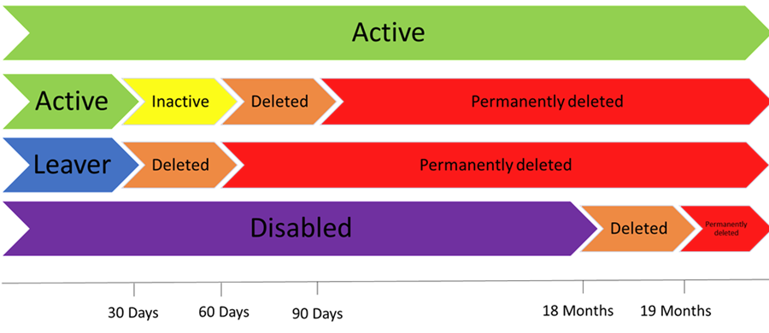
What do I need to do?
Undertaking at least one of the following activities every 30 days will keep your NHSmail account active:
o Log into the NHSmail portal
o Log into O365 application
o Use O365 applications (i.e., Outlook with cached credentials)
o Send an email
If you no longer require your NHSmail account, please contact : National Administration Service (NAS) – NHSmail Support who can process the closure of your account.
This change will be implemented on 1 December 2022.

BMJ Leader Live Event

When: 24 February 2023
Where: St Paul’s, London
The NHS Leadership Academy are pleased to be a supporting partner of BMJ Leader Live 2023.
This one day event aims to provide health and care professionals with the support and skills necessary to become better leaders, by providing delegates with access to expert-led content, practical workshops and coaching opportunities.
Find out more and register today. For any questions, please contact clinicalLeadership@leadershipacademy.nhs.uk
Early bird offer ends on 25 January. Clinicians are eligible for the one-day concessionary rate.

Talking Dental System Reform webinar tonight

Pro dental CPD is hosting two webinars on Dental System Reform, aimed at supporting dental teams on recent reforms.
The first webinar covered the changes announced in July 2022, with Simon Hearnshaw, Ali Sparke, Rachel Foskett-Tharby, Rebecca Harris and Paul Gray as speakers. This included information from the BSA about completing new FP17 fields. The recording of this can be accessed here.
The second system reform webinar focuses on Skillmix and takes place today, Wednesday 11 January at 7pm. Registration is free and can be accessed here. We hope to see you there.
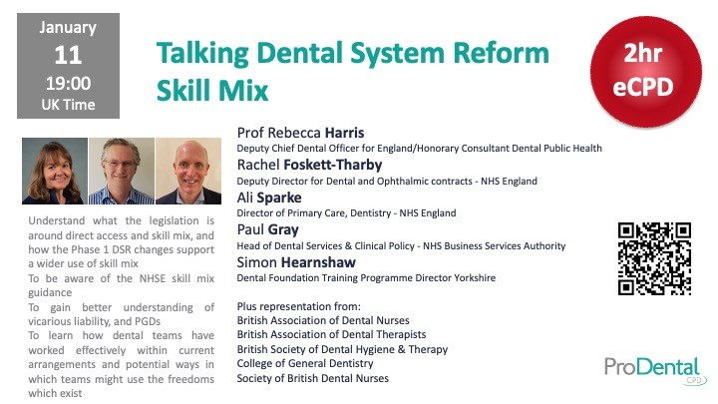

Practitioner Health Mental Wellbeing App

The Practitioner Health Mental Wellbeing App is now available to any member of the primary care team. You can register for the app using the access code PC2022 and you will then be sent joining details. The app is a personalised mental wellbeing tool, creating a wellbeing plan based on individual scores and customised content based on your identified needs and directing you to tools, resources and routes to support.

Signing up to this bulletin

Have you been sent this bulletin by someone else?
This bulletin is a round up of all the latest news and important resources for anyone working in NHS dental services. We'll send it out as and when important news needs to come your way. If you've already signed up but didn't receive the update, then check your junk folder for the confirmation email and make sure you've followed the instructions to complete sign up.
Click here to sign up to this bulletin

Recent dentistry and oral health bulletins
Previous bulletins can be accessed by clicking on the links below:
- Issue 27: 30 September 2021
- Issue 28: 12 October 2021
- Issue 30: 29 October 2021
- Issue 34: 25 November 2021
- Issue 36: 9 December 2021
- Issue 37: 22 December 2021
- Issue 38: 13 January
- Issue 39: 19 January
- Issue 40: 25 January
- Issue 41: 1 February
- Issue 42: 11 February
- Issue 43: 4 March
- Issue 44: 11 March

- Issue 45: 5 April
- Issue 46: 22 April
- Issue 47: 11 May
- Issue 48: 1 June
- Issue 49: 28 June
- Issue 52: 26 August
- Issue 53: 20 October
- Issue 54: 3 November
- Issue 55: 14 November
- Issue 56: 30 November

Special focus bulletins
Chief Dental Officer Sara Hurley and the NHS team regularly produce 'special focus bulletins' on clinical priorities and key aspects of patient care. These bulletins summarise the key information dental teams need to know and act as a refresher, combining best practice, expert opinion and useful resources. If you would like to suggest a topic for a future special focus bulletin please email the CDO's team at England.CDOExecutive@nhs.net
- Issue 11: 12 February 2021: Special focus on domestic abuse
- Issue 15: 7 May 2021: Special focus on mouth cancer
- Issue 16: 17 May 2021: Special focus on learning disabilities and autism
- Issue 25: 14 September 2021: Special focus on paediatric dentistry and children's oral health
- Issue 29: 27 October 2021: Special focus on NHS dental clinical leadership
- Issue 31: 5 November 2021: Special focus on dentistry and the environment
- Issue 32: 9 November 2021: Special focus on mental health
- Issue 33: 22 November 2021: Special focus on dentistry and antimicrobial resistance (AMR)
- Issue 35: 30 November 2021: Special focus on mouth cancer prevention
- Issue 43: 4 March 2022: Special focus on dementia
- Issue 51: 3 August 2022: Special focus on safeguarding

NHS primary care bulletin
The NHS primary care bulletin provides resources on health policy and practice and we encourage you to sign up for this, too. It is aimed at teams across general practice, dentistry, community pharmacy and optometry.
Click here to sign up to the NHS primary care bulletin

Key advice, guidance and resources for NHS dental teams

NHS updates to the profession
Key letters from the Chief Dental Officer and the NHS dentistry and oral health team are online here.

Infection prevention control (IPC)
NHS practices should refer to the NHS England Infection Prevention and Control Manual which details the principles NHS dental practices should now follow to deliver care. The accompanying dental framework identifies hazards and risks with guidance on measures that should be maintained as we move to new, improved and safer ways of working.

Dental recall priorities for children: implementation tool
Children are a clinical priority group for all NHS dental teams. Practices are encouraged to use the NHS implementation tool which assists dental professionals in the recall of children for a dental appointment, in line with NICE guidelines. You can view the tool online.

Avoidance of doubt note: provision of phased treatments
This document is to support dental professionals, and to clarify where it might be appropriate to provide phased treatment spanning over several courses of treatment (CoT). You can read it online here.

Health and wellbeing support
Click here for health and wellbeing support for NHS teams
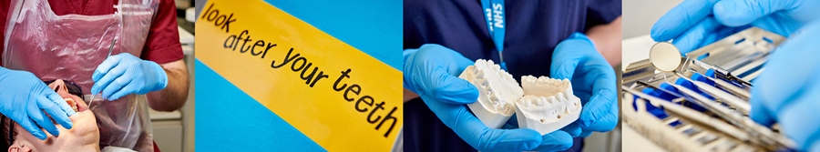

NHS England and NHS Improvement

